

CHINMORE INDUSTRY CO., LTD

*Specification*

*1.Product Type: Adhesive LTE ANT*

*2.Frequency: 824~960/1710~2170/2700 MHz (LTE)*

*3. Cable: RG174U*

*4.Connector: SMA M*

*※RoHS Compliant*

|  |  |  |  |  |
| --- | --- | --- | --- | --- |
| Frequency  (MHz) | Return Loss  (dB) | VSWR | Efficiency  (%) | Gain  (dB) |
| 824 | -13.52 | 1.58 | 27.35 | -1.57 |
| 880 | -12.62 | 1.60 | 36.22 | -0.53 |
| 960 | -10.13 | 1.98 | 24.83 | -1.3 |
| 1710 | -14.61 | 1.49 | 45.5 | 2.44 |
| 1880 | -18.76 | 1.26 | 73.11 | 5.16 |
| 2170 | -16.25 | 1.36 | 57.54 | 3.61 |
| 2700 | -12.59 | 1.60 | 38.55 | 3.05 |

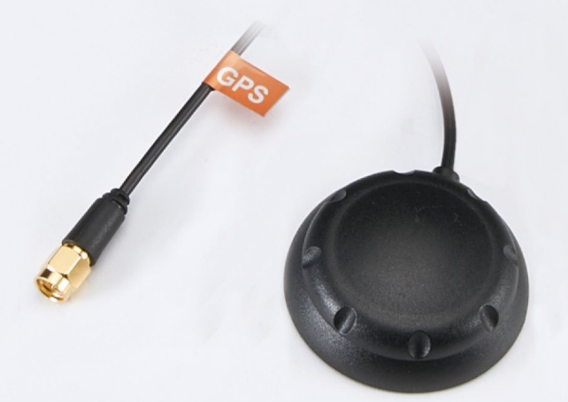

Test Report (Return Loss &VSWR)

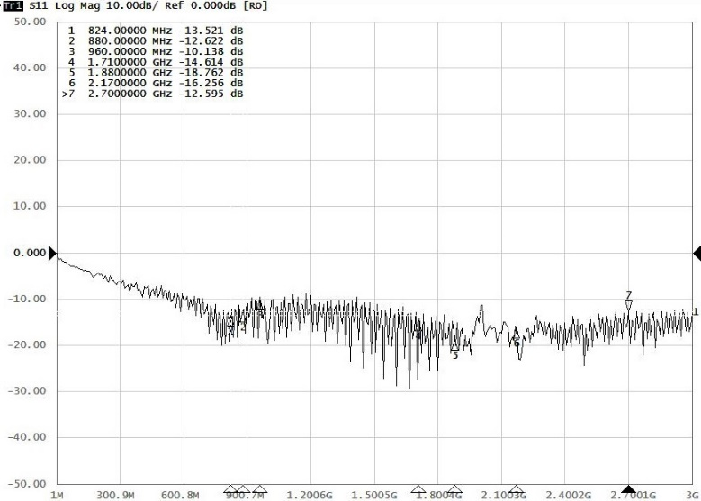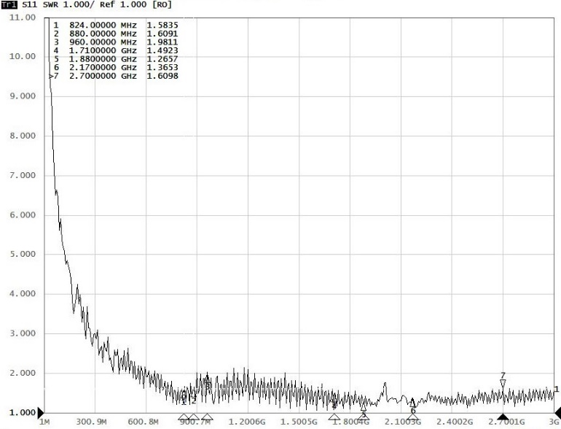

3D Test Data

